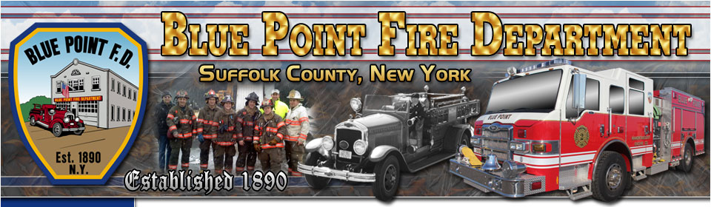

2019
ANNUAL REPORT
James A. Schmidt
Chief of Department

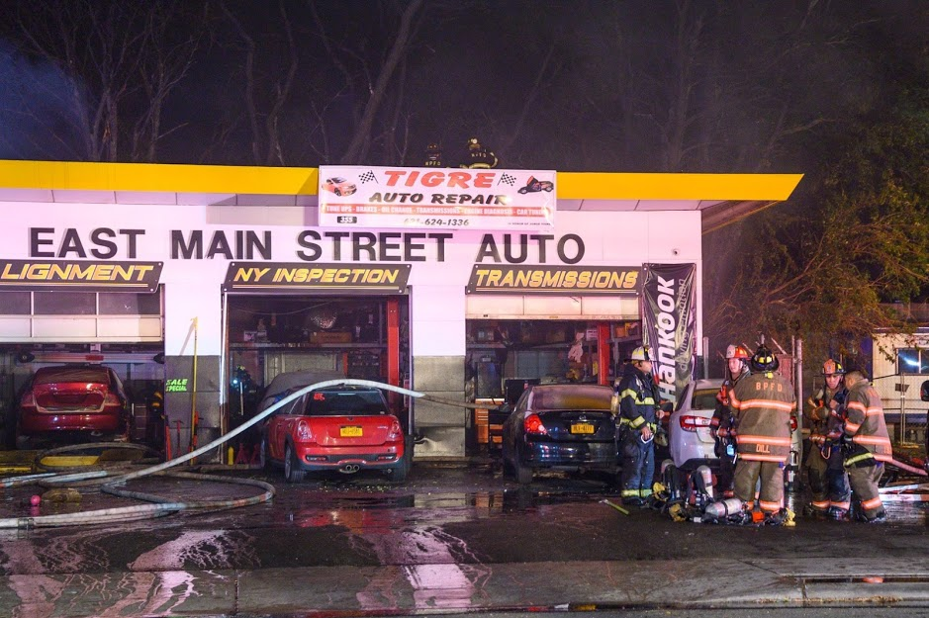

Table of Contents

Pages
Mission Statement…………………………………………… 3
Organizational Chart………………………………………… 4
Administration………………………………………………. 5
Training……………………………………………………… 6
Run Statistics………………………………………………… 7, 8
Apparatus……………………………………………………... 9
Fire Department Events……………………………………… 10

Mission Statement
The primary purpose of this volunteer fire department shall be the preservation of life and property from fires and emergencies in the area known as the Blue Point Fire District, assisting other fire departments and emergency service agencies and in firematic activities in general.

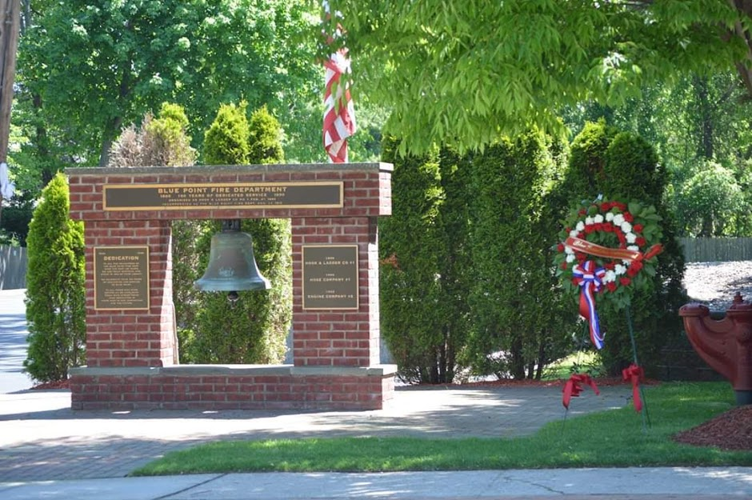

Organizational Chart

In January of 2019 the department saw a change in leadership from the previous year. James A. Schmidt took over the reins of Chief of Department after serving four years as an assistant chief. I would like congratulate and thank our most recent Ex-Chief Travis Salvo for all of his accomplishments and hard work in his time as chief. Tom Smith was elected to 1st Assistant Chief after serving two years as 2nd assistant chief and Sean Meehan was elected to 2nd Assistant Chief after serving as the hook and ladder company captain the previous two years.
Engine Company elected Ex-Chief Larry Stadier to the rank of company captain, he succeeded Captain Travis Meehan. Travis would soon be deployed in the coming months to the Middle East with his military reserve unit. Lieutenant Jon Galasso remained as the company lieutenant.
Hook and Ladder Company also saw a change in their officer ranks with Lieutenant Jesse Wenk being elected company captain and Firefighter Robert Scofield Jr. to lieutenant.
Hose Company officers remained the same with Captain Thomas Reilly continuing to lead the company with Lieutenant George Larson Jr.
There were also some administrative officer changes with Ex-Captain Todd Furchert assuming the role as Chairman of the Department from Firefighter Dave Beattie and Ex-Captain Rich Swedborg taking over as Department Treasurer from Ex-Captain Doug Miller. I would like to thank all the current and former officers for their hard work and dedication in their respective positions over the years.

Administration
From Chief James A. Schmidt…
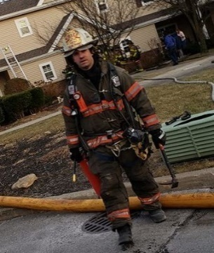
In 2019 the Blue Point Fire Department continued to improve the level of service we provide to the community by upgrading and replacing many different pieces of equipment and expanding our role in emergency responses within our jurisdiction.
Some of the equipment included the replacement of the multi-gas detectors on all front- line apparatus and our chief vehicles. These meters allow the members to detect hazardous materials such as carbon monoxide, dangerous levels of flammable vapors, as well as other harmful substances found in the home and workplace. The department also replaced a thermal imaging camera on the ladder truck that was no longer able to be repaired by the manufacturer and added three additional thermal imaging cameras (one for each chief’s vehicle). These invaluable tools allow firefighters to locate heat signatures created by fire and also to locate potential victims that may be trapped by fire or smoke.
The fire department was also called upon for assistance from the Patchogue Ambulance Company, who provide emergency medical services for the residents of Blue Point Fire District. With their significant increase in call volume and limited manpower, they requested the fire department to assist them with cardiac arrest incidents within our fire district. The need for early CPR and immediate application of an AED can greatly affect the survivability rate of the patient. This proved true when a 16-year-old boy was revived by our firefighters prior to the arrival of EMS personnel on August 17, 2019. That young man is alive today due to the quick action and training of the firefighters that evening. In total, our members were called upon seventeen times for persons in cardiac arrest making an impact on each incident.
The fire department continued to actively work on our recruitment and retention program throughout the year, which brought our largest group of probationary firefighters in recent years. In total the department added five new members, including three of our junior firefighters who completed their time with our junior program. During the year we also had two members resign from the rolls of the department. The year also brought the unfortunate loss of three members of our department. Michael Friscia Jr. one of junior firefighters, was tragically killed while on vacation in Florida. The department received an out pouring of support from all of our neighboring fire departments and junior firefighter programs from across Long Island. I can’t begin to thank our entire membership for supporting Michael, his family, and everyone who was involved in this unfortunate incident. The fire department also lost Ex-Chief Ed Davis and Honorary Firefighter and town historian Gene Horton. The loss of these individuals has certainly left a tremendous void in our fire department and the community.
Our 2019 Annual Report is a reflection of the commitment to the community we serve. The information and statics identify ways in which we challenge ourselves to continue to meet our mission and enhance our department.

Training & Fire Prevention

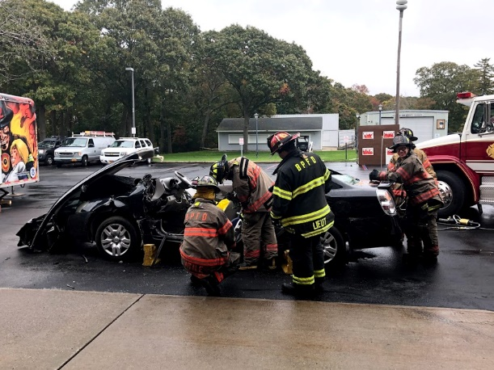
The members of the fire department continued to improve their skills as firefighters by participating in trainings and drills throughout the year. The classroom and hands-on sessions were completed at the Suffolk County Fire Academy, the Blue Point Fire Department training facility, as well as at our neighboring fire departments. The course work included but was not limited to; structural firefighting scenarios, vehicle extrication, search and rescue, firefighter survival and rapid intervention training, mayday and bail-out scenarios, incident command and radio communications, water rescue, hazardous material incidents, and driver training.
Our firefighters attended 110 different training courses for a total of just under 2,000 manpower hours of instruction throughout the year. This time does not include the countless hours that were put in to provide the community with fire safety education. This past year, our dedicated staff hosted over 250 elementary school aged children to teach them about fire safety during the month of October. They also changed the instructional portion of the program by providing live demonstrations of vehicle extrication for the older students in attendance. This change received great feedback from the students and teachers from the school. They also attended the annual fire safety education day at the local Home Depot. There, they spoke with members of the community of various ages about home fire safety, fire and carbon monoxide alarms, and general safe practices at home and in the workplace. We also hosted the homeowner’s association of a condominium complex that was recently built within our district to educate them on the new state of the art fire protection systems installed in their residences. The event was well attended by the HOA and the fire department received much praise for assisting them with understanding these new systems.

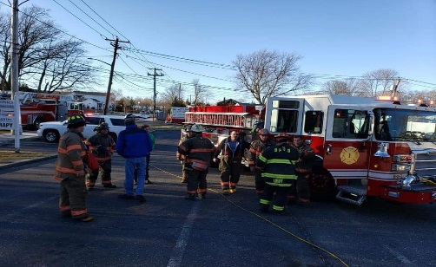
Run Statistics

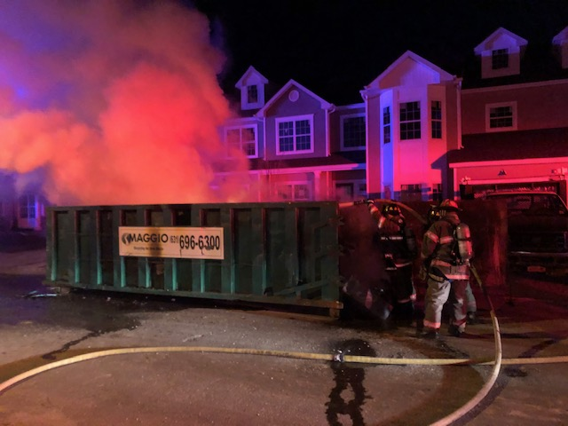
In 2019 the Blue Point Fire Department responded to a total of 258 alarms, which represents a consistent increase over previous years. The increase in call volume continues to trend in the upward direction as neighboring jurisdictions continue to request automatic mutual aid for assistance and the ever-growing demands for service with new multiple dwelling complexes and commercial development being built in the area. In comparison, in 2009 the Blue Point Fire Department responded to just 182 total alarms.

Run Statistics Continued…

The Blue Point Fire Department averaged 21.5 alarms per month in 2019.
There were no alarms that were reactivated as working fires during 2019, but the instances of reported fires or responses to neighboring fire districts for working fires were up from years past. On two separate occasions the Blue Point Fire Department was activated for reported building fires in occupied multiple dwellings within our fire district, to find the fires were both extinguished prior to our arrival by the presence of automatic fire sprinkler systems. These sprinkler systems limited the damage to the areas of origin, with minimal fire damage suffered to the residences. This allowed the occupants to safely evacuate their homes without injury or death. There were also several instances where automatic fire alarm activations were received in commercial buildings within the district and small incipient stage fires were located within the structures. There were no fire related fatalities or injuries to firefighters or residents in Blue Point in 2019.
With the increased call volume and a decrease in the number of volunteer firefighters today, the need for automatic mutual aid with neighboring fire districts is becoming increasingly necessary. In 2019 the Blue Point Fire Department responded on 40 automatic mutual aid alarms to neighboring fire districts and 4 non-automatic requests. The mutual aid responses included;
15- Automatic mutual aid calls for reported structure fires.
12- Automatic mutual aid calls for working structure fires including one fatal fire in North Patchogue.
11- Automatic mutual aid calls for water rescue incidents.
4- Non-automatic mutual aid calls for working structure fires.
2- Non-automatic mutual aid calls for miscellaneous incidents.
Apparatus

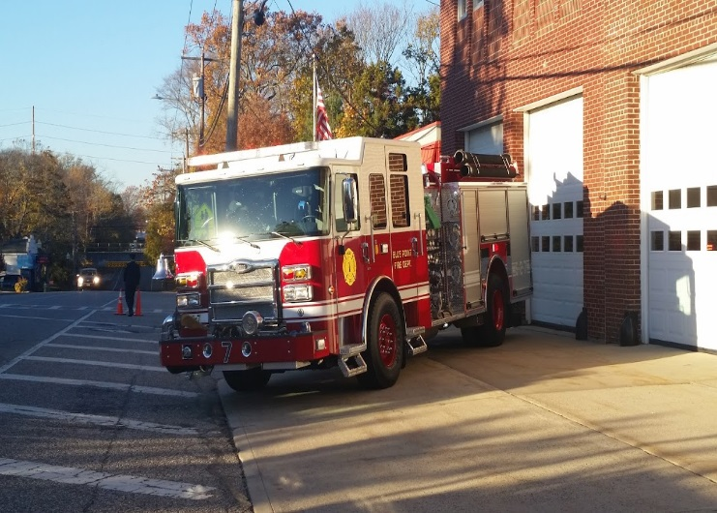
This past year the fire department down sized our fleet when it was determined that engine 5-2-6 was no longer cost effective to keep in service. Engine 6 was a 1990 Pierce Engine with a 1500gpm pump and a 500-gallon tank. It was the first apparatus purchased with a fully enclosed cab after NFPA deemed riding on the back step of apparatus was dangerous for firefighters to respond to calls in that manner. Engine 6 was sold to the Blue Point Brewery in Patchogue, who plan to repurpose the apparatus as mobile tap and show piece for the newly renovated building. All other front-line apparatus remained in service throughout the year except when maintenance and minor repairs were required.
The department still maintains a fleet of 2- Class ‘A’ Engines, 1- Quint style 77’ Ladder Truck, a Heavy Rescue Truck, 2- Boats, 1 Brush Truck, and numerous support vehicles.

There was 796 front line fire apparatus and utility vehicle responses in 2019, totaling over 425 hours of vehicle use throughout the year. Engine 2 responded on the most runs, followed by Engine 7. Rescue 10 was the most active vehicle for the truck company.
Fire Department Events

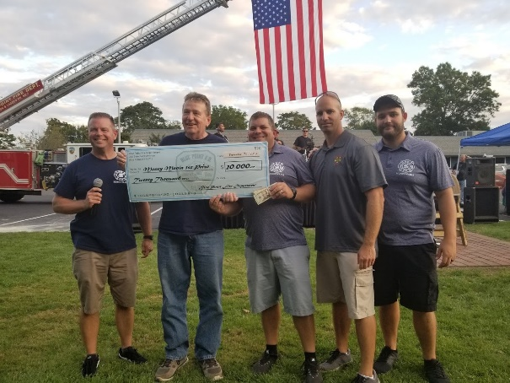
The members of the department continued to be actively involved in the community throughout the year. The fire department participated in multiple parades throughout the year including; the Chamber of Commerce St. Patrick’s Day parade, the Bayport-Blue Point little league parade, the Blue Point and Sayville Memorial Day parades, the High School Homecoming parade, and the Patchogue Village Christmas parade.
2019 was also another successful year for the department in regards to our fundraising efforts. Our annual Money Mania fundraiser sold out again for the 7th year since its inception in 2012. This continues to be our most successful fundraiser along with the Psychic Night with Jeffrey Wands in November. These funds allow us to support the recruitment and retention of members, the junior firefighter program, local community groups and scholarship funds for graduating seniors at Bayport-Blue Point High School. I want to thank our membership and the community for all of their continued support.
The junior firefighter program also had another successful year winning numerous trophies for their performance in competitive tournaments throughout the season. Their best finish of the season was 4th place after a tough fought battle in the final events at the Hagerman tournament on June 14th. The Junior Mighty Midgets won the Sportsmanship Award (an award voted on by coaches from every team) for their perseverance in overcoming tragedy early in the season and for their continued respect and dedication they show on the track each week. I would like to thank Ex-Chief Tom Nicholson, Ex-Captain Doug Miller, Firefighter Ray Maggi and all the members of the department who continue to make this program a great success.

Closing Statement
The Blue Point Fire Department successes are due to the dedication of our firefighters, as well as the support of our community and its leaders. We cannot meet our mission or vision without this dedication and support. I would like to thank everybody for a successful year and look forward to continue to improve our service in 2020.

Respectfully,

James A. Schmidt
Chief of Department

